**Total 4 web pages (Home, Committees, Curriculum map, News$Events)**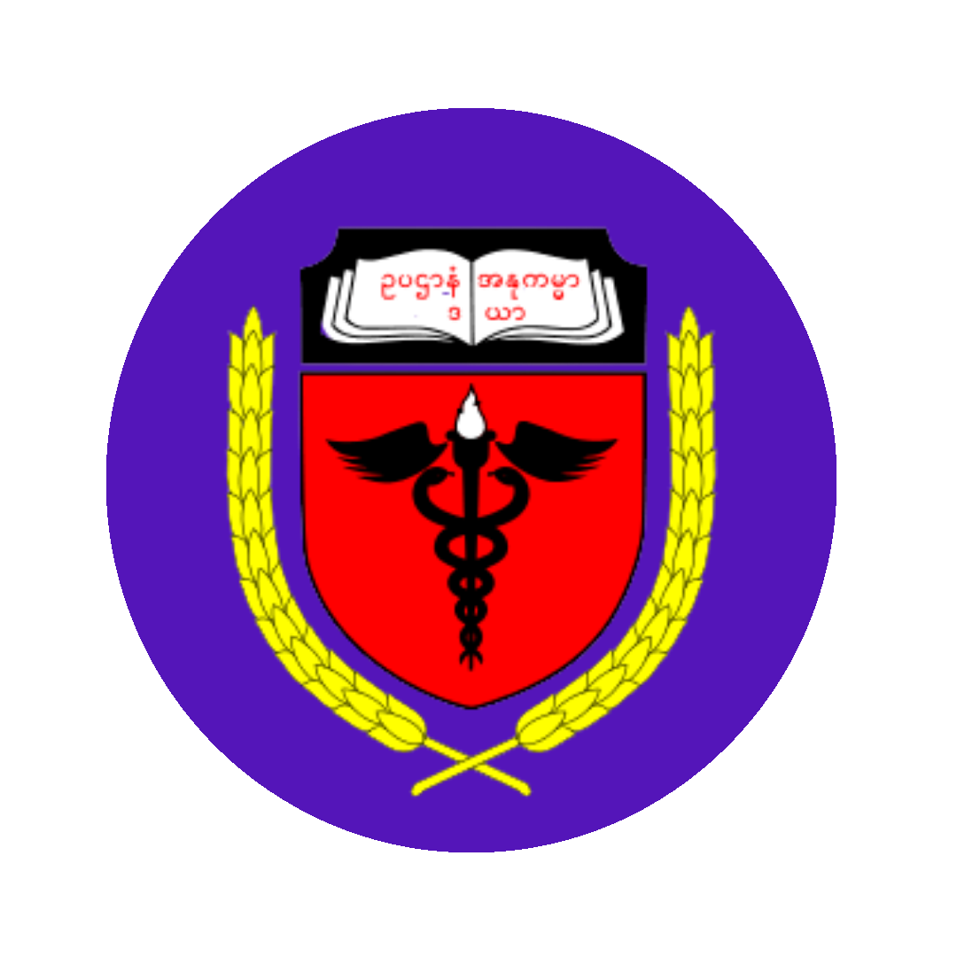

**UNIVERSITY OF MEDICINE, MAGWAY** [interimcouncil.ummg@protonmail.com](mailto:interimcouncil.ummg@protonmail.com)

+959****** *****

**________________________________________________________________________________**

**HOME IUC ACADEMICS NEWS&EVENTS CONTACT**

(linked to HOME tab)

**About UMMG**

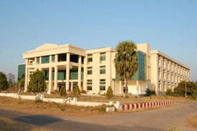

University of Medicine Magway (UMMG) is one of the five medical universities in Myanmar. It is located 7 miles east of Magway Township, Magway Division, Myanmar. UMMG is reputed as the Union University as many students from different places of the country come to attend.

After the coup de ’tat, along with the establishment of federalism, we are in a transitional period to be an autonomous university.

**Vision statement**

The University of Medicine, Magway aspires to be an autonomous learner-focused university which provides standard medical education and produces competent medical doctors.

**Mission statement**

The University of Medicine, Magway is committed to providing a conducive learning environment which can provide fundamental knowledge, skills, attitude and personal development to its students and promote research culture and innovations.

**Timeline of UMMG**

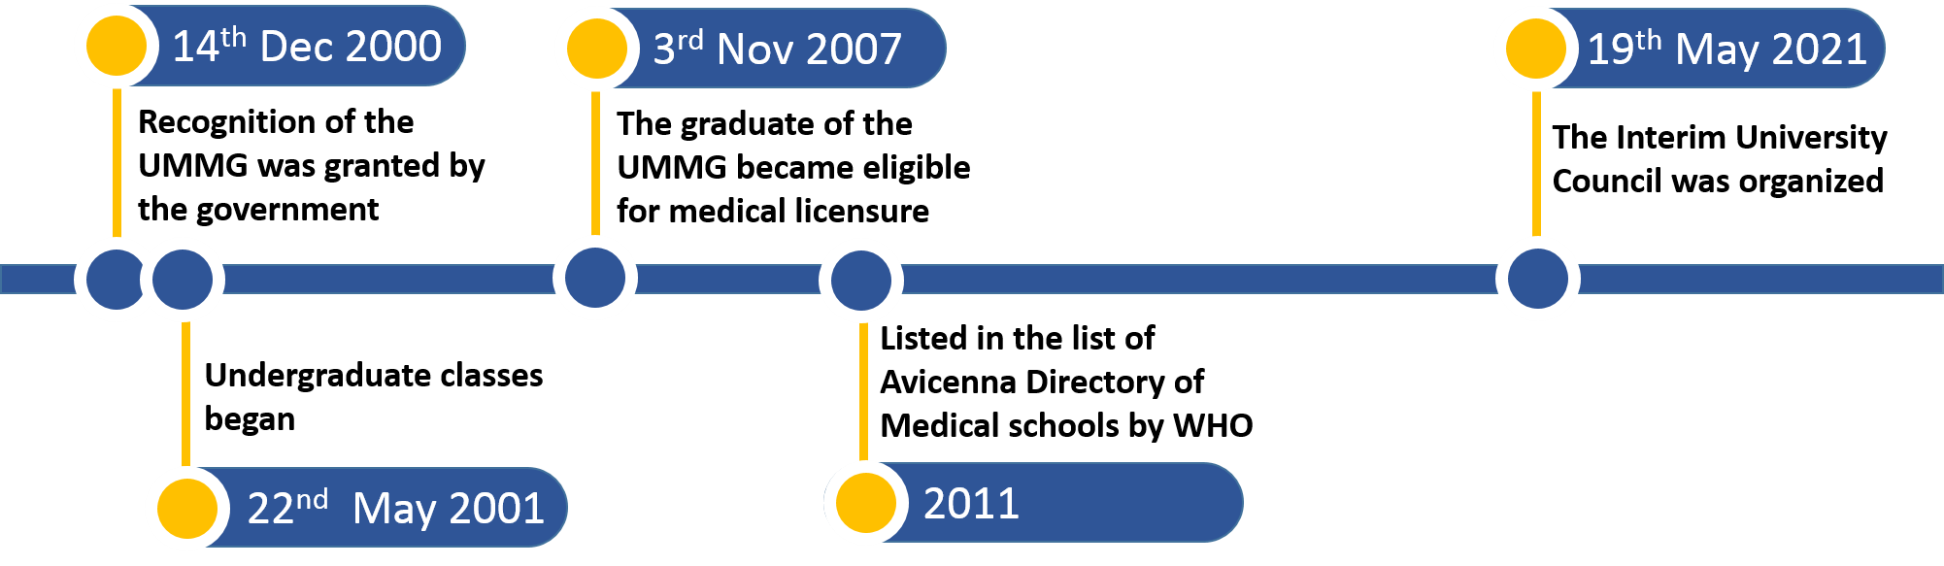

(linked to IUC tab)

**Interim University Council**

On February 1, 2021, the coup de ‘tat started in Myanmar. The people protested

the coup through a wide range of non-violent methods most notably Civil

Disobedience Movements initiated by doctors, nurses and medical professionals.

Schools and universities protested education under military rule by closing

down.

The Interim National Unity Government, the legitimate government of Myanmar, was

formed and was recognized as the legitimate government of Myanmar by the

mass. The Interim University Council (IUC) of UMMG was organised on 19 May 2021 and

the Interim National Unity Government recognized the Council as the highest

authority of the University on 30 May 2021.

The council's power is derived from the students, teachers and staff of the

university.

**The core committees of IUC**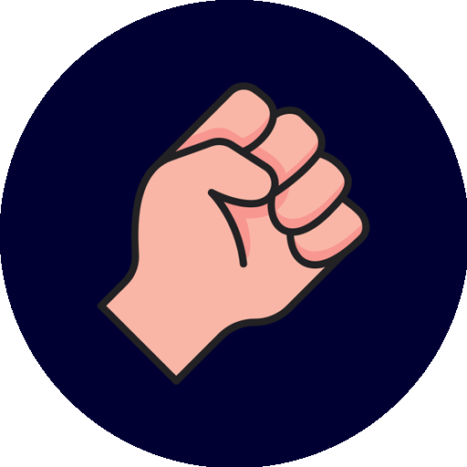

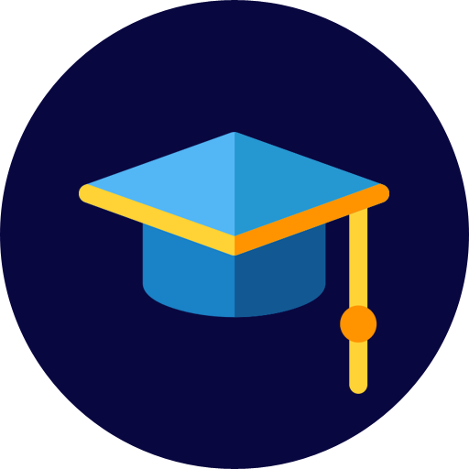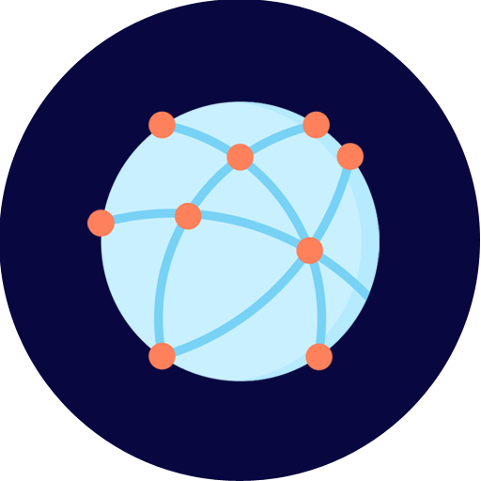

(Statements for the committee in three columns)

The Academic Committee is responsible for developing and executing academic policies and of the council and academic programs for teachers and students.

The Global Engagement Committee is responsible for the provision of the engagement of UMMG with the parallel institutions and institutions abroad.

The CDM committee is responsible to give support to CDM staff and CDM students during the interim period.

See more about the committees (Linked to another page)

______________________________________________________________________________

(linked to ACADEMICS tab)

**Academic programs**

The UMMG currently offers MBBS degree programs, M.Med.Sc. degree programs, and PhD programs in medical science.

**The curriculum of undergraduate programs**

The current curriculum is a Traditional discipline-based curriculum, consisting of knowledge and attitude acquired on the basis of learning medical courses, followed by training for pre-clinical subjects which cover basic medical science subjects, public health subjects and legal medicine. Students who pass the summative assessments are forwarded to clinical years. Then a one-year compulsory internship program ensues. The whole course extends over 7 years.

**Outcome-based Integrated Curriculum (OBIC)**

Recently, an outcome-based Integrated Curriculum (OBIC) was introduced in 2020 based on the following domains:

• Medical knowledge

• Patient care

• Practice-based learning

• System-based practice

• Ethics and professionalism

• Interpersonal and communication skills.

The duration of the course is 6 years, composed of Foundation Year (FY), Pre-clinical years (M1 & M2), and clinical years (M3, M4 and M5).

The OBIC is not fully developed and the developing process was interrupted because of the coup.

**Curriculum Map of OBIC** (Hyperlink text အဖြစ် page တခုကိုချိတ်ရန်)

**Current academic programs**

For the present time, as the right to education is being oppressed by the military, the IUC developed a virtual online campus to continue delivering education to CDM students.

The online campus is a Moodle-based learning platform and the learning materials are being uploaded.

As the outcome-based integrated curriculum is not fully developed, the education on the online campus is based on the traditional discipline-based curriculum.

Go to UMMG online campus ( http://learn.ummg-campus.org ကို link အဖြစ်အဖြစ်ချိတ်ရန်)

**How to register for UMMG online campus**

All CDM students are eligible for registering for the UMMG online campus.

Contact via this Telegram Link (http://t.me/ummgcampus ကို link ချိတ်ရန်) to register.

—-----------------------------------------------------------------------------------------------------------------------

(Linked to COLLABORATION tab)

**Collaborations**

IUC is in strategic collaboration with UMMGSU (linked to https://www.facebook.com/ummgsu) and UMMGAA (linked to https://www.facebook.com/UMMGAlumniAssociation ) .

* UMMGSU (UMMG Students Union) is organized with UMMG students. UMMGSU is actively collaborating with IUC to deliver academic opportunities to the students and to give support to the CDM staff.
* UMMGAA (UMMG Alumni Association) is organized with UMMG alumni and carries out several activities related to humanitarian aids and human rights. UMMGAA is in close collaboration with UMMGIUC and is actively involved in activities to give support to CDM staff and students.

________________________________________________________________________________

(Linked to NEWS&EVENTS tab)

**Latest News** (newest maximum 3 ခု ပြရန်) 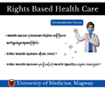

(Image thumbnails and headings)

Rights-based Health Care Course စီစဉ်ဖွင့်လှစ်ခြင်း

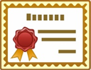

‌နောက်ဆုံးနှစ်အပိုင်း(ခ) သင်တန်းပြီးမြောက်အောင်မြင်ကြောင်း အသိအမှတ်ပြုလက်မှတ်များ ပေးအပ်ခြင်း



**Contact us**

office@ummg-campus.org 

+959*********

UMMG Moodle site (learn.ummg-campus.org)

Facebook page of IUC (https://www.facebook.com/iucummg/)

Telegram Link to register (http://t.me/ummgcampus)

Telegram information channel (<http://t.me/infoummgiuc>)

(Separate Committee page)



The Academic Committee is implementing academic programs for teachers and students.

The academic programs include

* Capacity building/knowledge sharing programs for teachers
* Creating courses for undergraduate students
* Creating extracurricular courses for personal and professional development

The academic committee manages the academic affairs of the students.

The academic committee also develops the academic policies to be applied for the interim as well as future academic programs.



The Global Engagement Committee serves to get and strengthen the engagement between the IUC and other relevant institutions.

The currently collaborating institutions/organization include

* The interim councils of other medical/medical-related universities
* The Myanmar Medical Diasporas Association

The activities of the committee also include seeking and providing opportunities to participate in international academic programs for the teachers and students.



The CDM committee is responsible to give support to CDM staff and CDM students during the interim period.

The activities of the committee include

* Developing CDM policies for staff and students
* Maintaining and strengthening the engagement between IUC and the CDM staff and CDM students
* Managing the welfare of the CDM staffs and CDM students

**(Separate page)**

**Curriculum Map of Outcome-Based Integrated Curriculum**

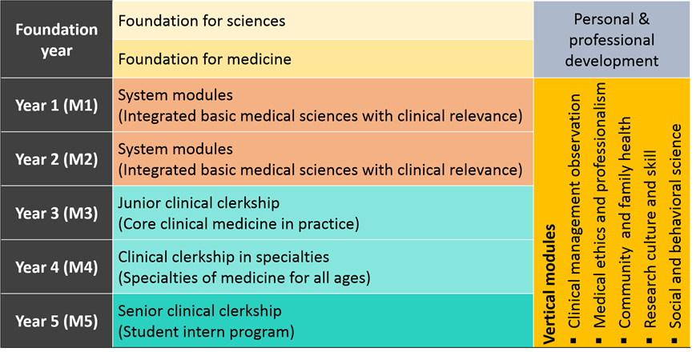

(Separate page)

**News and Events**

ဆေးနဲ့ဆေးနှီးနွယ်အဝန်းအဝိုင်းက မောင်နှမတွေ၊ ကျောင်းသားကျောင်းသူတွေအတွက်

Rights based Health Care ဆိုတဲ့ Extracurricular course တစ်ခုကို UMMG IUC က စီစဉ်ထားပါတယ်။ ဒီ Course မှာတော့ Health sector နဲ့ Human Rights အကြား ဆက်နွှယ်နေတဲ့ အကြောင်းအရာတွေကို ရှုထောင့်စုံ၊ ကဏ္ဍစုံကနေ ပညာရှင်တွေက တစ်ပတ်တစ်ခါ Zoom Live session နဲ့ မျှဝေပေးသွားမှာဖြစ်ပါတယ်။ ပြီးသွားခဲ့တဲ့ Live session များကိုလည်း Recorded video အနေနဲ့ UMMG learning platform မှာ ပြန်လည်တင်ပေးထားဦးမှာဖြစ်တဲ့အတွက် Course enrollment ပြုလုပ်ပြီး မိမိအဆင်ပြေတဲ့အချိန်မှာ ဝင်ရောက်လေ့လာနိုင်ပါတယ်။ အသေးစိတ်ကိုတော့ facebook page နဲ့ telegram info channel မှာ ဖတ်ရှုနိုင်ပါတယ်။



‌နောက်ဆုံးနှစ်အပိုင်း(ခ) နောက်ဆက်တွဲသင်တန်းသား/သူများကို 2022 ခုနှစ် August လတွင် စာမေးပွဲစစ်ဆေးပြီး သင်တန်းပြီးမြောက်အောင်မြင်ကြောင်း အသိအမှတ်ပြုလက်မှတ်များ ပေးအပ်ခဲ့ပါသည်။